Article issued from MV’s Chronicle, Museum Volunteers’s newletter, 10, June-August 2015

Talented MV
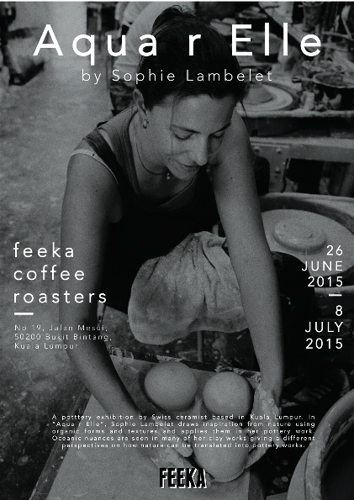
From 26 June to 8 July 2015, Sophie Lambelet MV from batch 23 exhibited her last ceramic artworks in a solo exhibition titled Aqua r elle at Feeka coffee in Kuala Lumpur. Sophie is a Swiss national who grew-up in a small village called Confignon in the
Geneva district. She started to play with clay as a kid and learned pottery’s skills from her father. She finds her inspiration in nature, and enjoys observing the dversity of shapes, textures and patterns it offers. Her last work consists mostly in round shapes. She uses little round vases or «stones» to creat paths .
For more information: sophielambelet.com
